### **EduVerse: An AI-Powered Multilingual Chatbot with AR for Personalized Learning and Career Development**

### 

### **Project Objectives (Enhanced with AR Technology):**

· **Enhance Learning Engagement**

* Introduce interactive and immersive AR-based learning experiences, such as 3D models and holographic displays, to increase student interest and motivation.
* Replace static resources like textbooks and lectures with dynamic, visually appealing content.

· **Personalize Education**

* Leverage AI to provide tailored learning experiences, adapting to each student’s progress, strengths, and weaknesses.
* Offer customized course recommendations and quizzes to meet individual learning needs.

· **Bridge Theory and Practice**

* Help students connect theoretical knowledge with real-world applications through AR models (e.g., plant anatomy, physics simulations).
* Provide visual explanations for complex concepts, making learning more intuitive and practical.

· **Promote Multilingual Education**

* Implement real-time speech translation and subtitles via AR/VR to eliminate language barriers in classrooms.
* Enable students to learn and communicate in their preferred language, enhancing inclusivity.

· **Support Educators**

* Reduce teacher workload by automating repetitive tasks, such as generating quizzes, grading, and summarizing lecture content.
* Provide AI-powered chatbots for student assistance, freeing up teachers for higher-value activities.

· **Increase Accessibility**

* Use cost-effective hardware like Raspberry Pi and Google Cardboard to make advanced learning tools affordable and scalable.
* Ensure offline compatibility and low-bandwidth functionality to support underserved regions with poor internet infrastructure.

· **Foster Lifelong Learning**

* Develop tools that encourage curiosity and critical thinking, nurturing a lifelong passion for learning.
* Offer features like gamified progress tracking and AR Trophy Rooms to sustain engagement over time.

· **Empower Language and Communication Skills**

* Provide AR/VR-based grammar learning and pronunciation guides for enhanced communication development.
* Utilize immersive, context-based experiences to improve professional language skills.

· **Reduce Dropout Rates**

* Address disengagement in traditional education systems by offering adaptive, engaging tools.
* Support students in underserved communities, increasing retention rates and academic success.

### **Design (With AR Integration):**

The design of the AI-driven educational tool with AR integration is focused on creating a seamless, interactive, and immersive learning experience. Below is a detailed breakdown:

### **1. System Architecture**

**User Layer**:

* + **Students**: Access AR-based quizzes, 3D models, and learning materials via mobile devices or Raspberry Pi systems.
  + **Teachers**: Use dashboards for content creation, monitoring progress, and automating tasks like grading.
  + **Administrators**: Manage system access, user permissions, and app deployment across devices.

**Application Layer**:

* + AR-based modules for interactive content delivery.
  + AI-powered recommendation engine and chatbot for personalized support.
  + Progress tracking and gamification features for user engagement.

**Data Layer**:

* + Cloud-hosted databases for real-time updates and content storage.
  + Local storage on Raspberry Pi for offline functionality.

### **2. AR/VR Module Design**

**AR Quizzes and 3D Models**:

* + **Feature**: Interactive AR-based quizzes triggered by scanning study materials or objects.

**Progress Tracking (Gamification)**:

* + **Feature**: A 3D "AR Trophy Room" visualizes user achievements, such as badges, trophies, or virtual avatars.

**AR Learning Materials**:

* + **Feature**: Textbooks or study materials, when scanned, display animations or holograms explaining key concepts.

**Pronunciation Learning**:

* + **Feature**: AR guides animate mouth movements and break down words into syllables for pronunciation practice.

**Topic Summarization**:

* + **Feature**: Summarize long texts into interactive bullet points in AR.

**Mental Health Support**:

* + **Feature**: Friendly AR avatars provide comforting messages, breathing exercises, or focus tips.

**3. Hardware Integration**

**Raspberry Pi Systems**:

* + Equipped with touch displays running Raspberry Pi OS.
  + Connectivity via GSM modules for remote and low-bandwidth environments.
  + Institutional password management for secure access.

**ESP32 Integration for Audio**:

* + Captures and processes teacher’s audio in real-time for translation or transcription.
  + Broadcasts translated audio via Bluetooth/Wi-Fi to students’ headsets.

### **4. Front-End Design**

**Mobile Applications**:

* + Developed using Flutter or React Native for cross-platform support.
  + Responsive design ensures usability across devices, including smartphones, tablets, and Raspberry Pi systems.

### **5. Back-End Design**

**API Development**:

* + Flask/Django (Python) for managing requests between the front-end and back-end.
  + RESTful APIs for retrieving AR content, user progress data, and chatbot responses.

**Database**:

* + **Firebase Realtime Database**: For real-time updates and user data syncing.
  + **NoSQL Database (MongoDB)**: For storing AR models, animations, and user-generated data.

**AI Modules**:

* + NLP for chatbot conversations and summarization of text.
  + Speech-to-text for real-time audio transcription and translation.

### **6. AR Data Pipeline**

**Dynamic AR Rendering**:

* + Scene recognition algorithms using ARCore/ARKit to map real-world objects and overlay 3D models.

**Interactive Features**:

* + Event-driven AR interactions (e.g., tapping, swiping, or voice commands).

### **7. Security and Privacy**

**Data Encryption**:

* + End-to-end encryption for user data storage and transmission.
  + OAuth2 for secure login and authentication.

**Privacy Controls**:

* + Role-based access for administrators, teachers, and students.
  + GDPR-compliant data handling for international scalability.

### **8. Key AR Features in Action**

**Interactive MCQs**:

* + AR overlays present questions based on scanned objects or diagrams.
  + Distractors (wrong answers) appear as alternative 3D objects.

**Coding Assistance with AR**:

* + Visualize code execution in real-time using AR overlays.
  + Highlight errors and show flowcharts to debug code interactively.

**Language Translation for Videos**:

* + Floating AR subtitles for live translation during lectures or video content playback.

**Career Guidance in AR**:

* + AR dashboards visualize career paths, required skills, and timelines.

### Methodology

The methodology involves designing and implementing an **AI-driven educational tool integrated with AR (Augmented Reality)** to address challenges in traditional education. The approach incorporates:

1. **Problem Identification:** Analyzing gaps in engagement, accessibility, and personalization in current educational methods.
2. **Technology Selection:** Leveraging AI models (GPT, Dialogflow), and IoT integration with Raspberry Pi systems for implementation.
3. **Feature Development:** Developing interactive learning tools, including:
   1. AR-based MCQs, 3D models, and topic summaries.
   2. Language support with AR-guided pronunciation and real-time translation.
   3. Personalized recommendations and progress visualization.
   4. AR-powered chatbots for instant assistance.
4. **Feasibility Analysis:** Assessing technical, economic, and operational feasibility using scalable cloud infrastructure and affordable devices.

ARCHITECTURE DIAGRAM:

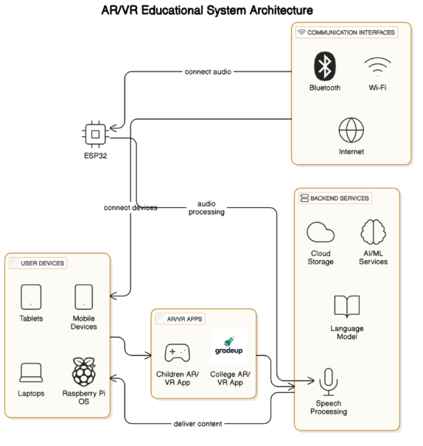

### Implementation

The system integrates multiple layers:

**Front-End Development:**

* 1. Interactive UI with Unity3D and React Native.
  2. AR animations triggered by visual markers or scanned documents.

**Back-End Development:**

* 1. AI models for language processing and personalized recommendations.
  2. Speech-to-text, translation, and chatbot integration via cloud services.

**IoT Integration:**

* 1. Raspberry Pi systems for classroom interaction.
  2. Connectivity modules (GSM) for remote access.

**Cloud Services:**

* 1. Databases (Firebase, MongoDB) for data storage.
  2. APIs for authentication, data processing, and content delivery.

**User Experience:**

* 1. AR-enabled apps with interactive study materials and feedback mechanisms.
  2. Progress tracking via 3D AR environments.

### Results

The implementation yielded several benefits:

1. Enhanced student engagement through immersive AR experiences.
2. Improved comprehension and retention of concepts via interactive learning.
3. Scalability demonstrated with multi-device compatibility.
4. Reduced teacher workload with AI-powered assistants and automated summaries.

### Conclusion

The AI-driven educational tool demonstrated the potential to transform learning experiences by:

1. Bridging gaps in traditional education with interactive, personalized tools.
2. Offering cost-effective solutions for institutions with minimal infrastructure.
3. Preparing students for future careers by introducing cutting-edge technology.
4. Enhancing accessibility, especially in underserved regions.